**IMDB Movie Analysis**

**Project Description:** This project isabout IMDB Movie Analysis. I was provided with the dataset having various columns of different IMDB Movies. I was required to provide a detailed report for the below data record mentioning the answers of the questions that follows:

1. **Movie Genre Analysis:** Analyze the distribution of movie genres and their impact on the IMDB score.

**My Task:** Determine the most common genres of movies in the dataset. Then, for each genre, calculate descriptive statistics (mean, median, mode, range, variance, standard deviation) of the IMDB scores.

1. **Movie Duration Analysis:** Analyze the distribution of movie durations and its impact on the IMDB score.

**My Task:** Analyze the distribution of movie durations and identify the relationship between movie duration and IMDB score.

1. **Language Analysis:** Situation: Examine the distribution of movies based on their language.

**My Task:** Determine the most common languages used in movies and analyze their impact on the IMDB score using descriptive statistics.

1. **Director Analysis:** Influence of directors on movie ratings.

**My Task:** Identify the top directors based on their average IMDB score and analyze their contribution to the success of movies using percentile calculations.

1. **Budget Analysis:** Explore the relationship between movie budgets and their financial success.

**My Task:** Analyze the correlation between movie budgets and gross earnings, and identify the movies with the highest profit margin.

**Approach:** First Igone through dataset to know all the columns present in the table. Then I saw all the questions and thought of functions which could be used to answer each question. After that I applied those functions and found the answer to each question and plotted the graph wherever was required. I started with cleaning the data set using following steps:

* First, I deleted all the unwanted columns which were: color, director_facebook_likes, actor_3_facebook_likes, actor_1_facebook_likes, cast_total_facebook_likes, facenumber_in_poster, plot_keywords, actor_2_facebook_likes, aspect_ratio.
* After that I removed all the rows with blank cells. For this first, I selected whole table. After that, I selected go to special option inside find & select menu. Inside the menu I selected blanks option and all the blank cells were selected. Then I simply deleted the rows which consists those blank cells.
* Lastly, I removed all the duplicate rows.

Link for cleaned data :-

<https://docs.google.com/spreadsheets/d/1GHW0M2VqPRlTDKSleDtSgmGEIAcq7bvh/edit?usp=sharing&ouid=106942457558004201317&rtpof=true&sd=true>

**Tech-Stack Used:** The software used for the project is Microsoft Excel 365. It is used to run the functions and get answers of each question. It is also used to plot the graphs.

**Insights:**

1. Movie Genre Analysis:

Function:-

=IF(ISNUMBER(SEARCH("|",Table_IMDB_Movies[@genres])),LEFT(Table_IMDB_Movies[@genres],SEARCH("|",Table_IMDB_Movies[@genres])-1),Table_IMDB_Movies[@genres])

=UNIQUE(V2:V3768)

=COUNTIF(F$2:F$3768,"*" & X2 & "*")

=AVERAGEIF(F$2:F$3768,"*" & X2 & "*",R$2:R$3768)

=MEDIAN(IF(ISNUMBER(SEARCH("*" & X2 & "*",F$2:F$3768)),R$2:R$3768))

=MODE(IF(ISNUMBER(SEARCH("*" & X2 & "*",F$2:F$3768)),R$2:R$3768))

=MAXIFS(R$2:R$3768,F$2:F$3768,"*" & X2 & "*")

=MINIFS(R$2:R$3768,F$2:F$3768,"*" & X2 & "*")

=VAR(IF(ISNUMBER(SEARCH("*" & X2 & "*",F$2:F$3768)),R$2:R$3768))

=STDEV(IF(ISNUMBER(SEARCH("*" & X2 & "*",F$2:F$3768)),R$2:R$3768))

Output:-

<https://docs.google.com/spreadsheets/d/1SwIZECZBaX83YIgE7s_fAiMSR1AVUm2f/edit?usp=sharing&ouid=106942457558004201317&rtpof=true&sd=true>

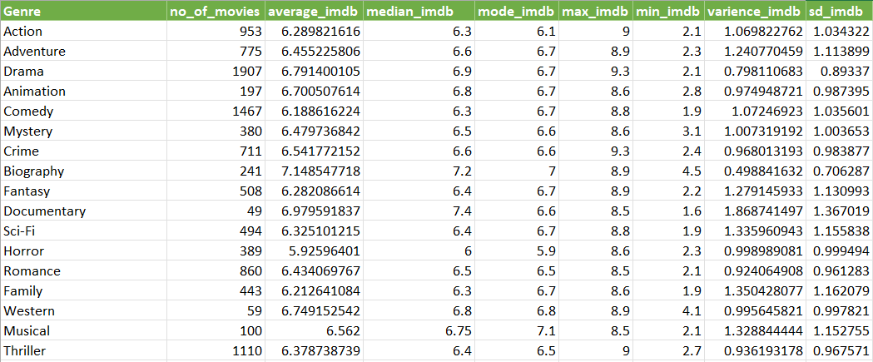

1. Movie Duration Analysis:

Function:-

=AVERAGE(C2:C3768)

=MEDIAN(C2:C3768)

=STDEVA(C2:C3768)

Output:-

<https://docs.google.com/spreadsheets/d/1a3f0MsCE5PHjF2Dn7WTYn9tZekDIO7F-/edit?usp=sharing&ouid=106942457558004201317&rtpof=true&sd=true>

|  |  |
| --- | --- |
| **movie_duration** |  |
| **mean** | 110.1972392 |
| **median** | 106 |
| **standard deviation** | 22.70305467 |

1. Language Analysis:

Function:-

=UNIQUE(M2:M3768)

=COUNTIF(M$2:M$3768,U2)

=AVERAGEIF(M$2:M$3768,U2,R$2:R$3768)

=MEDIAN(IF(M$2:M$3768=U2,R$2:R$3768))

=STDEV(IF(M$2:M$3768=U2,R$2:R$3768))

Output:-

<https://docs.google.com/spreadsheets/d/1cmXAIl9iLqLw3nV1WU8y3tSw62Kij-Q8/edit?usp=sharing&ouid=106942457558004201317&rtpof=true&sd=true>

|  |  |  |  |  |
| --- | --- | --- | --- | --- |
| **language** | **no_of_movies** | **mean_imdb** | **median_imdb** | **stand_imdb** |
| English | 3593 | 6.42599499 | 6.5 | 1.049712558 |
| Mandarin | 14 | 7.021428571 | 7.25 | 0.765786244 |
| Aboriginal | 2 | 6.95 | 6.95 | 0.777817459 |
| Spanish | 23 | 7.082608696 | 7.2 | 0.860577065 |
| French | 36 | 7.297222222 | 7.25 | 0.565425812 |
| Filipino | 1 | 6.7 | 6.7 | #DIV/0! |
| Maya | 1 | 7.8 | 7.8 | #DIV/0! |
| Kazakh | 1 | 6 | 6 | #DIV/0! |
| Telugu | 1 | 8.4 | 8.4 | #DIV/0! |
| Cantonese | 8 | 7.2375 | 7.3 | 0.440575922 |
| Japanese | 12 | 7.625 | 7.8 | 0.899621132 |
| Aramaic | 1 | 7.1 | 7.1 | #DIV/0! |
| Italian | 7 | 7.185714286 | 7 | 1.155318962 |
| Dutch | 3 | 7.566666667 | 7.8 | 0.404145188 |
| Dari | 2 | 7.5 | 7.5 | 0.141421356 |
| German | 13 | 7.692307692 | 7.7 | 0.640912811 |
| Mongolian | 1 | 7.3 | 7.3 | #DIV/0! |
| Thai | 3 | 6.633333333 | 6.6 | 0.450924975 |
| Bosnian | 1 | 4.3 | 4.3 | #DIV/0! |
| Korean | 5 | 7.7 | 7.7 | 0.570087713 |
| Hungarian | 1 | 7.1 | 7.1 | #DIV/0! |
| Hindi | 8 | 7.175 | 7.3 | 0.761108215 |
|  | 2 | 5.3 | 5.3 | 0.707106781 |
| Icelandic | 1 | 6.9 | 6.9 | #DIV/0! |
| Danish | 3 | 7.9 | 8.1 | 0.529150262 |
| Portuguese | 5 | 7.76 | 8 | 0.978774744 |
| Norwegian | 4 | 7.15 | 7.3 | 0.574456265 |
| Czech | 1 | 7.4 | 7.4 | #DIV/0! |
| Russian | 1 | 6.5 | 6.5 | #DIV/0! |
| None | 1 | 8.5 | 8.5 | #DIV/0! |
| Zulu | 1 | 7.3 | 7.3 | #DIV/0! |
| Hebrew | 1 | 8 | 8 | #DIV/0! |
| Dzongkha | 1 | 7.5 | 7.5 | #DIV/0! |
| Arabic | 1 | 7.2 | 7.2 | #DIV/0! |
| Vietnamese | 1 | 7.4 | 7.4 | #DIV/0! |
| Indonesian | 2 | 7.9 | 7.9 | 0.424264069 |
| Romanian | 1 | 7.9 | 7.9 | #DIV/0! |
| Persian | 3 | 8.133333333 | 8.4 | 0.550757055 |
| Swedish | 1 | 7.6 | 7.6 | #DIV/0! |

1. Director Analysis:

Function:-

=UNIQUE(A2:A3768)

=AVERAGEIF(A$2:A$3768,V2,R$2:R$3768)

=PERCENTRANK.EXC(W$2:W$1694,W2)

=INDEX(SORTBY(V2:W1694,X2:X1694,-1,V2:V1694,1),SEQUENCE(10),{1,2})

=AB2-AVERAGE(W$2:W$1694)

To compare the scores of top directors to the overall distribution of scores I subtracted average imdb score from imdb score of the director.

Output:-

<https://docs.google.com/spreadsheets/d/11wWcvzX2oJnM-TvFBJpJpqaH7SDqdFCW/edit?usp=sharing&ouid=106942457558004201317&rtpof=true&sd=true>

|  |  |  |  |
| --- | --- | --- | --- |
| **Rank** | **top10director** | **idmb_score** | **greater_than _average_score** |
| 1 | Charles Chaplin | 8.6 | 2.287152896 |
| 2 | Tony Kaye | 8.6 | 2.287152896 |
| 3 | Alfred Hitchcock | 8.5 | 2.187152896 |
| 4 | Damien Chazelle | 8.5 | 2.187152896 |
| 5 | Majid Majidi | 8.5 | 2.187152896 |
| 6 | Ron Fricke | 8.5 | 2.187152896 |
| 7 | Christopher Nolan | 8.425 | 2.112152896 |
| 8 | Sergio Leone | 8.433333333 | 2.120486229 |
| 9 | Asghar Farhadi | 8.4 | 2.087152896 |
| 10 | Richard Marquand | 8.4 | 2.087152896 |

1. Popular Genres:

Function:-

=[@gross]-[@budget]

=CORREL(P2:P3768,E2:E3768)

=IF(T2:T3768=MAX(T2:T3768),H2:H3768,"")

=INDEX(SORTBY(H2:H3768,T2:T3768,-1),SEQUENCE(5))

Output:-

<https://docs.google.com/spreadsheets/d/1IA7UlJ3YgYshWf3XKh6KGA8gbk76AqtE/edit?usp=sharing&ouid=106942457558004201317&rtpof=true&sd=true>

Movie with highest profit :- Avatar

|  |
| --- |
| **movies_with_highest_profit** |
| Avatar |
| Jurassic World |
| Titanic |
| Star Wars: Episode IV - A New Hope |
| E.T. the Extra-Terrestrial |

|  |  |  |
| --- | --- | --- |
|  |  |  |

**Results:**

Cleaning the data: Cleaned data consists of 3768 rows including title.

1. Movie Genre Analysis:

The impact of genre is almost same on mean, median, mode movie ratings

1. Movie Duration Analysis:

|  |  |
| --- | --- |
| **movie_duration** |  |
| **mean** | 110.1972392 |
| **median** | 106 |
| **standard deviation** | 22.70305467 |

1. Language Analysis:

English is most popular language.

1. Director Analysis:

Charles Chaplin is the director with highest imdb rating.

1. Budget Analysis:

Avatar is the movie with highest profit.